W1 PRACTICE
PART 2 – MANIPULATION

 Before this practice
- You need to have completed: PART 1- EXPLORATION

 What do you need to be able to do for next week?
- Identify the type of variable
- Manipulate nullable and non-nullable variables.
- Differentiate between final and const.
- Manipulate strings, lists, and maps.
- Use loops and conditions to control flow.
- Define and call functions with positional and named arguments, understand arrow syntax



 Are you lost?
Read the following documentation to be ready for this practice:

- Variables
- Null Safety
- Built-in types
- Lists
- Loops
- Conditions
- Functions

EX 1 – Manipulate Types
Are you clear about strings, integer, list, map, set, objects in Dart?
Examine the given data structures and write the inferred Dart type for each one (see example)

Notes
- First find by yourself the type
- If you need, double check your answer with VSCode.

Data | Dart Type
const studentGrades = {  'Sokan': [90, 85, 88],  'Sokea': [70, 80, 75],  'Hay': [95, 92, 89],  }; | Map<String, List<int>>
const pizzaPrices = {  'margherita': 5.5,  'pepperoni': 7.5,  'vegetarian': 6.5,  }; | Map<String, double>
const books = [  {'title': '1984', 'author': 'George Orwell'},  {'title': 'Brave New World', 'author': 'Aldous Huxley'},  {'title': 'Fahrenheit 451', 'author': 'Ray Bradbury'},  ]; | List<Map<String,String>>
const company = {  'HR': {'employees': 5, 'budget': 20000},  'IT': {'employees': 10, 'budget': 50000},  'Marketing': {'employees': 7, 'budget': 30000},  }; | Map <String, Map<String, int>>
const coordinates = [  [1, 2],  [3, 4],  [5, 6],  ]; | List<List<int>>
const productDetails = {  'id': 101,  'name': 'Laptop',  'price': 999.99,  'inStock': true,  }; | Map<String, Object>
const operations = [  (int a, int b) => a + b,  (int a, int b) => a - b,  (int a, int b) => a * b,  ]; | List<int function(int, int)>
const distances = {3.1, 5.5, 10.2, 7.8}; | Set<double>
const university = {  'departments': [  {  'name': 'Computer Science',  'students': [  {'name': 'Alice', 'age': 22},  {'name': 'Bob', 'age': 24},  ]  },  {  'name': 'Mathematics',  'students': [  {'name': 'Charlie', 'age': 21},  {'name': 'Dave', 'age': 23},  ]  }  ]  }; | Map<String, List<Map<String, Object>>>

EX 2 – Manipulate final and const
In this exercise, you need to decide which variable can be declared as const or final.

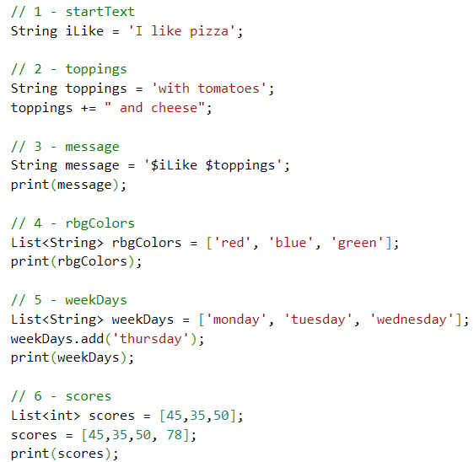

Guess which variables can be declared as const, final or var, and explain your choices.
Notes
- Read here to understand the concepts.
- Prefer const over final over var.

 | VAR, FINAL, CONST? | WHY
iLike | CONST | Because this variable never changes
toppings | Var | Because you can still add topping
message | final | Because it never reassign
rbgColors | const | it only read and do nothing else
weekDays | final | content modify not reassign
score | var | because the content have been modify and reassign

EX 3 – Filter a list
Write a Dart program that takes a list of exam scores and returns the scores of all students who passed

Given
- You are given a list of integers representing students' exam scores.
- A student passes if their score is 50 or higher.

Example input:
[45, 78, 62, 49, 85, 33, 90, 50]

Example output:
[78, 62, 85, 90, 50]

Requirements
Implement the filtering in two different ways.

Method 1 — Using a for loop
- Use a for loop to examine each score.
- Add passing scores (>= 50) to a new list.

Method 2 — Using where()
- Use where function to filter the list.
- Pass a proper anonymous function to where().

void main() {
List<int> Student= [45, 78, 62, 49, 85, 33, 90, 50];
for(int num in Student){
if (num >= 50) {
print(num);
}
}
}

List<int> passStudent = Student.where((Student) => Student >= 50).toList();
print(passStudent);

